Module 2 - Lab 1_Basic_Plots
PRE SESSION
Learnings from Code Base-
- Data visualization helps in understanding patterns and relationships in datasets more effectively than raw numerical data
- an automobile dataset is used to analyze relationships between variables
- commonly import the libraries and load the data ,defined the features and target columns
- then data processing was done
- the data was visualized
DURING SESSION
- The data was visualized correctly using appropriate plotting techniques.
- Highlighted a key mistake:
Using scatter plot for make vs price → leads to clutter and no meaningful interpretation
- Transition shown in class:
- Scatter Plot (ineffective for categorical data)
- Box Plot / Violin Plot (effective for comparison)
POST SESSION
- After the session, I experimented with different visualization techniques and preprocessing steps.
- Added extra plots
  - Scatter Plot
  - Box Plot
  - Violin Plot
  - Swarm Plot
  - Joint Plot
  - Subplots (Multiple Graphs)
Question: Interpreting Body Style vs. Price
Let's analyze the plot below, which shows the relationship between a car's body-style and its price.
Based on the plot, answer the following questions:
- Which body-type has the highest median price? Which one appears to be the "costliest" overall?
- Is looking only at the maximum value (the top whisker or outlier) a good way to determine the costliest body-style? Why is the interquartile range (the box) a better indicator?
- Do you think the body-style of a car could be a good predictor for its price? Why or why not?
ANSWERS
1)Highest Median & Costliest Body-Type
- -Convertible generally has the highest median price.
- -It also appears to be the costliest overall.
Reason:
- -The median line is highest among all body styles. -Price distribution is skewed toward higher values.
- -Often associated with luxury or premium cars.
2. Is maximum value a good indicator?
No, maximum value is not reliable because:
- -It may be an outlier (extreme value).
- -Represents only one or very few cars. Does not show the general trend.
3.Is body-style a good predictor of price?
- -Body-style is a weak to moderate predictor.
- -Should be used along with other features for better prediction.
- sns.boxplot(x=X["body-style"],y=y, palette="Set3").set_title('Body style vs Price Box Plot')
- /tmp/ipython-input-1765729027.py:1: FutureWarning:

- Passing `palette` without assigning `hue` is deprecated and will be removed in v0.14.0. Assign the `x` variable to `hue` and set `legend=False` for the same effect.

- sns.boxplot(x=X["body-style"],y=y, palette="Set3").set_title('Body style vs Price Box Plot')
- Text(0.5, 1.0, 'Body style vs Price Box Plot')
- 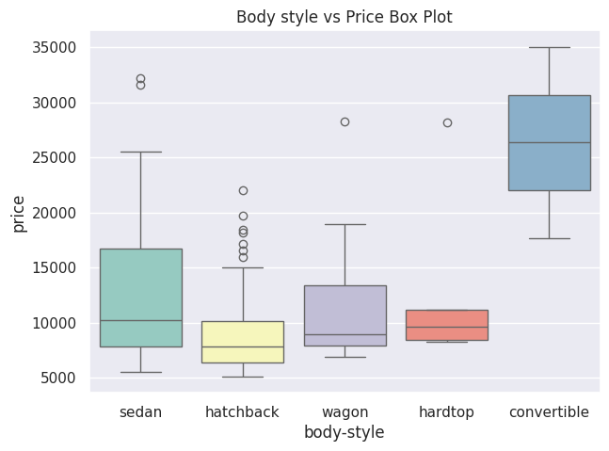
Exercise
Often, you want to display multiple plots side-by-side to compare them. Matplotlib's plt.subplots() function is perfect for this. It creates a figure and a grid of subplots (axes).

Task: Choose any 2 plot types discussed above (e.g., a Box Plot and a Violin Plot) and plot them together in a single figure for body-style vs. price.

fig, axes = plt.subplots(1, 2, figsize=(18, 7))

sns.boxplot(x=X["body-style"], y=y, palette="Set3", ax=axes[0])
axes[0].set_title("Body Style vs Price - Box Plot")
axes[0].tick_params(axis='x', rotation=45)

sns.violinplot(x=X["body-style"], y=y, palette="Set3", ax=axes[1])
axes[1].set_title("Body Style vs Price - Violin Plot")
axes[1].tick_params(axis='x', rotation=45)

plt.tight_layout()
plt.show()
plt.figure(figsize=(14, 7))
sns.swarmplot(x=X["body-style"], y=y, palette="Set2")
plt.title("Body Style vs Price - Swarm Plot")
plt.xticks(rotation=45)
plt.tight_layout()
plt.show()
/tmp/ipykernel_1279/2488122407.py:6: FutureWarning:

Passing `palette` without assigning `hue` is deprecated and will be removed in v0.14.0. Assign the `x` variable to `hue` and set `legend=False` for the same effect.

sns.boxplot(x=X["body-style"], y=y, palette="Set3", ax=axes[0])
/tmp/ipykernel_1279/2488122407.py:10: FutureWarning:

Passing `palette` without assigning `hue` is deprecated and will be removed in v0.14.0. Assign the `x` variable to `hue` and set `legend=False` for the same effect.

sns.violinplot(x=X["body-style"], y=y, palette="Set3", ax=axes[1])
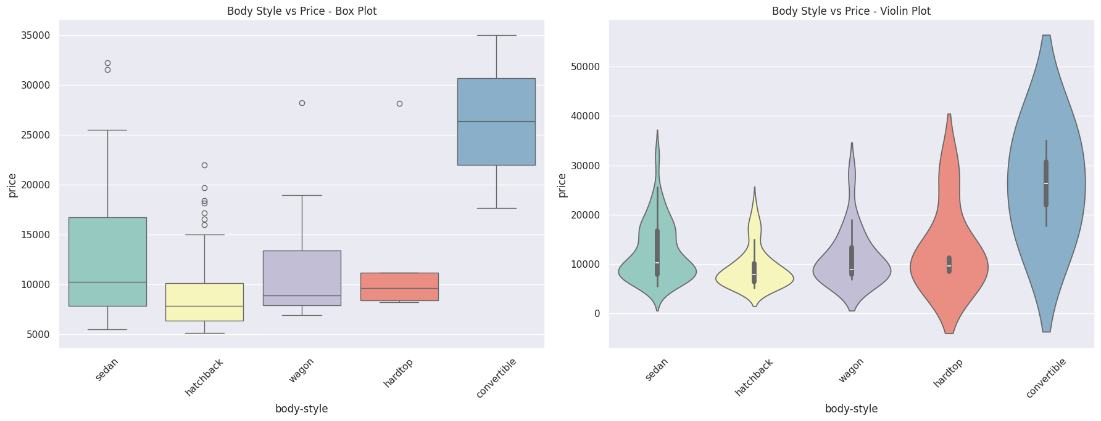
/tmp/ipykernel_1279/2488122407.py:17: FutureWarning:

Passing `palette` without assigning `hue` is deprecated and will be removed in v0.14.0. Assign the `x` variable to `hue` and set `legend=False` for the same effect.

sns.swarmplot(x=X["body-style"], y=y, palette="Set2")
